Why badge visitors?
So staff members know that any strangers in the building have been authorized and identified …
1. To be in this particular area
2. On this particular day
3. For this particular reason
(See customized examples below.)
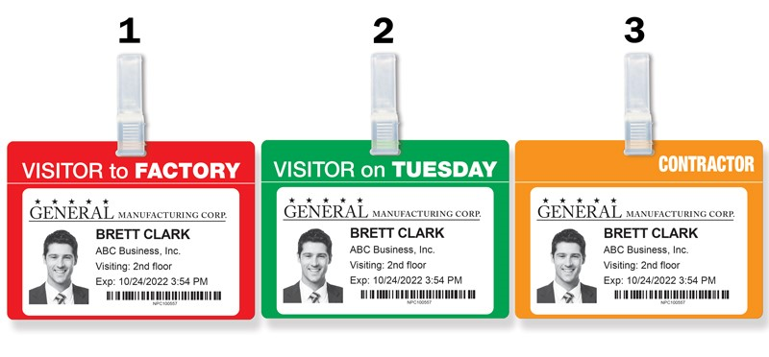
Applying adhesive visitor badges to large colorful Badge Tags helps answer questions about visitors at a glance. For example, these visitors have permission to be: (1) in the factory (as opposed to the office), (2) here today only if it’s a Tuesday, and (3) working in an area that’s under renovation.
By identifying visitors with essential information, you validate their presence at your facility.
By adding this information to bold, recognizable Badge Tags, you help others to see that validation more quickly.
Contact us today!

