Increase visitor security with the use of color:
Print IN Color, Print or Write ON Color, or Stick TO Color
There’s nothing like adding a little color to your visitor badges to make them stand out. Color also helps your staff quickly see, as they pass them in the hall, what kind of visitor is approaching, what day of the week they signed in, and where they are approved to go.
Print IN color
Use expiring visitor badges printed on color inkjet printers.
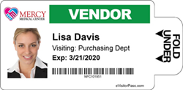 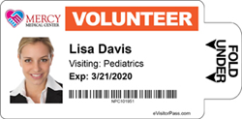
Color-coded visitor badges by type of visitor.
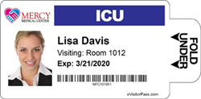
Color-coded visitor badges by department.
Print or write ON color
THRESHOLD now offers direct thermal color badges.
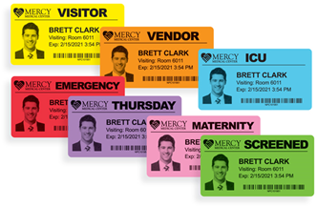
7 colors to choose from.
Stick TO color
If you are using white visitor badges with a direct thermal printer, like DYMO, Brother, or Zebra, color coding can also be achieved using Color Badge Tags that easily identify visitors from a distance.
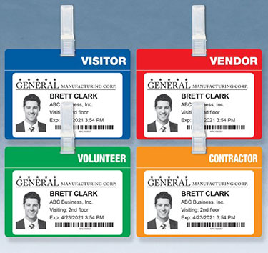
Custom and pre-printed color-coded Badge Tags.
Contact us today!

