Use our COVID stickers and badges for a safer workplace
Screened Solutions
Stickers and badges for knowing who has been screened.
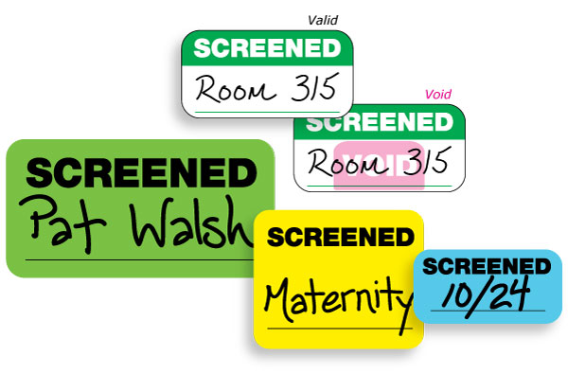
Vaccinated Solutions
Stickers and badges that help identify who has been vaccinated before they enter your building.
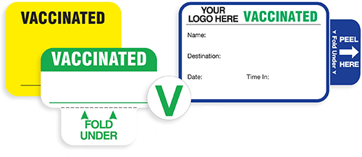
Contact us today!

