For your employees, patients, teachers, and visitors:
Protectors for their vaccination record cards
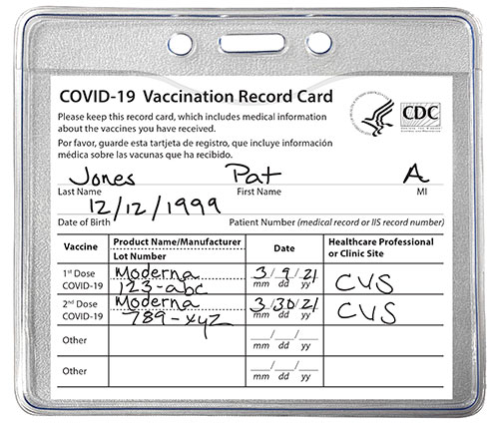
- A perfect fit for CDC COVID-19 Vaccine Cards
- Clear vinyl sleeve is sealed on three sides
- Record card stays protected from water and other damage to ensure they stay safe for future reference without lamination
- Card can be removed to add more information (like recording a booster shot)
Contact us today!

