Hello,
Do your vendors check in every time they visit? How do you know?
Make sure you can see your vendor is always using a valid badge. Our badges with EXPIRING technology change color over time so your vendors can’t reuse them to bypass your front desk.
VALID today... ...VOID tomorrow
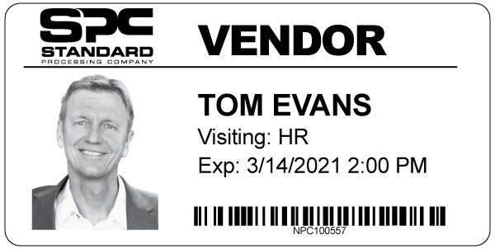 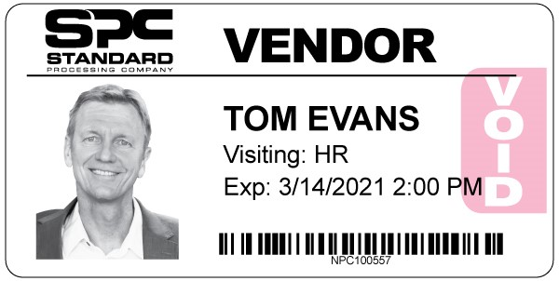
These adhesive badges work with vendor credentialing systems like Vendormate, Reptrax, and Symplr (VCS), as well as any other visitor management system that uses rolled direct-thermal or inkjet printers like these:
- DYMO
- Zebra
- Brother
- Epson
- Primera
Ask for free samples to try with your system, and start adding a layer of security to your vendor credentialing process.
Contact us today!

