Direct Thermal Visitor Badges now in color!
Color badges provide an instant alert.
- 7 bright colors for maximum visibility
- Color code by department, type of visitor or by days of the week
- Compatible with DYMO and Zebra direct thermal printers
- Fabric-friendly adhesive ensures the badge stays on.
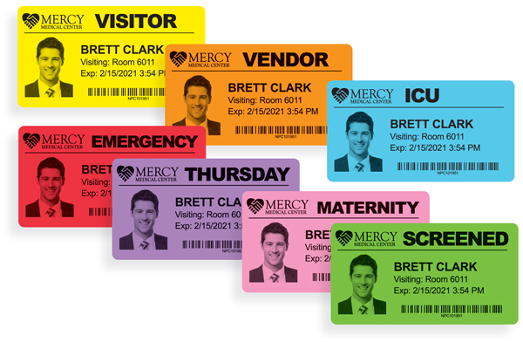
7 colors to choose from.
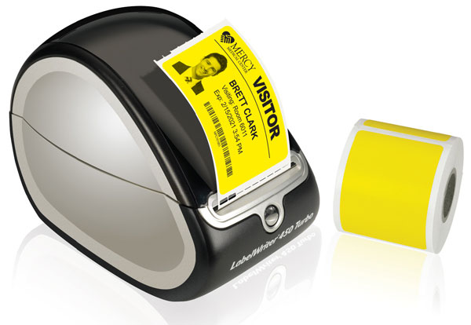
Shown in DYMO printer. Also compatible with Zebra printers.
SKU: #VDTN4-CLR
Price: $70 per 1,000 badges (250 badges per roll)
Contact us today!

