COVID stickers show which staff members, customers, outpatients, and visitors have been screened today
Every Expiring Screened Sticker shows a bright “VOID” the next day. This means it has expired and can’t be reused.
VALID today VOID tomorrow
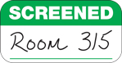 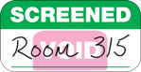
Write the NAME of the person being screened, write the DATE they were screened, or write their approved LOCATION, as shown.
Expiring Screened Stickers
2 5/16" x 1 3/16"
$112 for 1,000 stickers (on 2 rolls of 500 each)
Learn how these stickers show “VOID,” request free samples, or buy now.
Contact us today!

