Bright stickers show who has been screened today
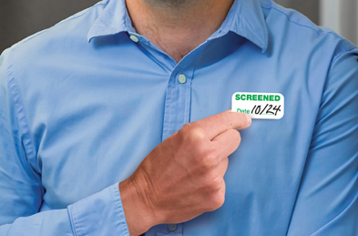
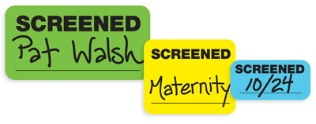
Your choice of size, format, and color, with space for you to describe the wearer — such as their name, where they are going, and the date they were screened.
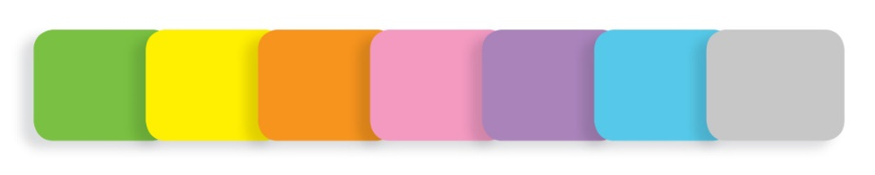
Choose from 7 solid colors, 5 border colors, and plain white, where available.
Stickers in a Book
Small Screened Stickers
3 ½" x 1 7/8"
11 color choices
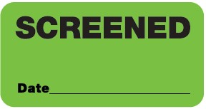
$41 for 500 stickers (in a book)
X-Small Screened Stickers
2 5/16" x 1 7/8"
7 color choices
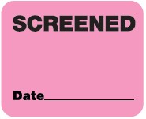
$51 for 675 stickers (in a book)
Stickers on a Roll
X-Small Screened Stickers
2 5/16" x 1 7/8"
7 color choices
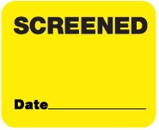
$34 for 500 stickers (on a roll)
Screened Stickers
2" x 1"
7 color choices
$25 per 500 stickers (on a roll)
2-roll minimum, any color combination
Expiring Screened Stickers
2" x 1"
White only
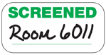 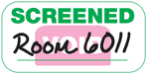​​​​​​​
VALID today, VOID tomorrow
$112 for 1,000 stickers (on 2 rolls of 500 each)
Contact us today!

