Bright stickers show who has been screened today
Your choice of size, format, and color. One extra-secure style even shows a bright “VOID” the next day. This means it has expired and can’t be reused.
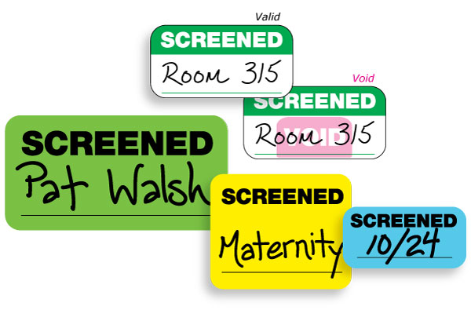
- Write the NAME of the person being screened
- Write their approved LOCATION
- Write the DATE they were screened
Contact Us Today!

