3 new software features manage your visitor capacity
Our exclusive eVisitor software now has three new features that help you limit the number of visitors in your facility.
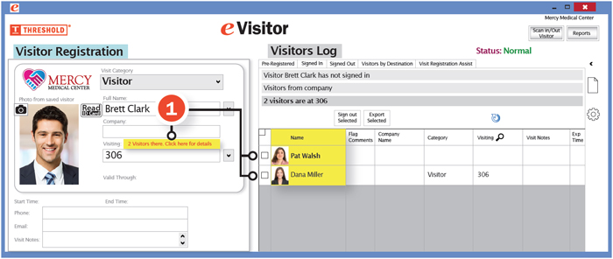
(1) Room-Track™ alerts you to how many visitors are in a room and who they are. As soon as you enter a room number, the red text appears as shown (if there are visitors already signed in to that room).
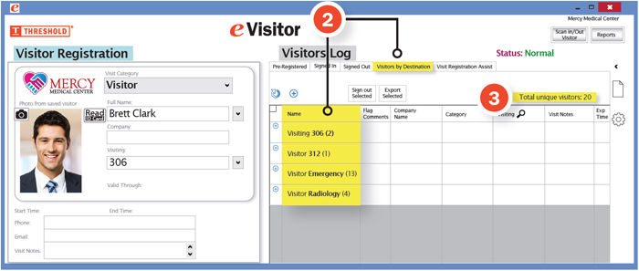
(2) The Visitors By Destination tab shows a list of all destinations that have visitors and the number of visitors in each. When you click on one of the rooms, you see who is visiting.
(3) Total Unique Visitors shows you at a glance how many visitors are in your entire facility.
Ask for a quick demonstration or brochure to learn more.
Contact us today!

