2 ways to collect information for contact tracing
When outsiders such as visitors, vendors, and contractors enter your facility, make sure you have a way to reach them after they leave. If someone else at your location tests positive for COVID, this information will help with contact tracing.

1. With eVisitor Software
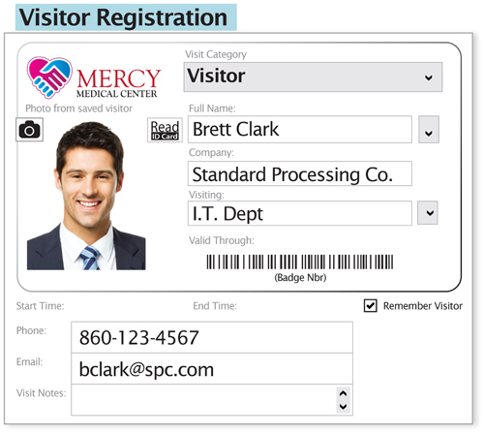
Our eVisitor software’s user interface prompts your desk attendant to collect a visitor’s contact information.
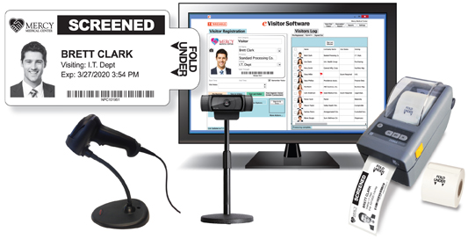
eVisitor software makes it easy to sign in, badge, and track visitors with cloud-based data access. Available for signing in visitors by your staff or for visitors to sign in themselves.
Contact us to learn more and request a free demonstration.

2. With Visitor Badge Sign-In Books
Enter the visitor’s phone number at sign-in on our exclusive Contact Stub, available with both TAB-Expiring and NON-Expiring Badges, shown below.
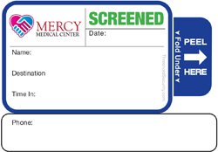  Style 824 | 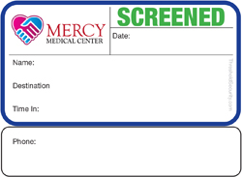  Style 722
Contact us today!

