10 Tips on Minimizing Contact with Visitors
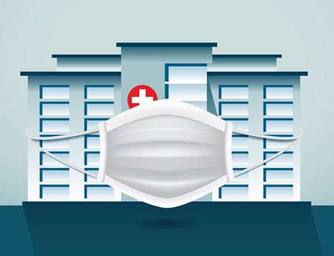
As you reopen your doors to visitors, you may wonder how to minimize the contact between them and your staff — especially those who are responsible for signing visitors in.
The following tips are both solution-specific and general, and may inspire other ideas for keeping your people safe. Contact us for help with implementation.
For signing in using an electronic, computerized system
1. Scan your visitors' driver’s licenses with a hand-held, “touchless” scanner. Even better, position it toward your visitors so they can scan their licenses themselves.
2. Face your printer toward your visitors, so they can tear it off themselves. This avoids your having to do it and then handing it to them. Some printer models even have cutters to make it easier to retrieve.
3. Have your visitors sign in using a kiosk. Install an anti-microbial screen on it or provide an anti-microbial stylus.
For signing in using a manual, handwritten system
4. Display two sets of pens — one marked “sanitized,” the other marked “used.” Ask your visitors to sign in using one of the sanitized pens and then place it in the used container, which could have a small opening to avoid confusion. Then, periodically, have a staff member sanitize the used pens.
In general
5. Install an acrylic barrier between your desk attendant and your visitors.
6. Provide hand sanitizer for visitors to use before and after they sign in.
7. Print and display instructions for any tasks your desk attendant would normally perform that you now want your visitors to do.
8. Request that visitors schedule their visits in advance by filling out an online form. This could include a brief questionnaire as part of your COVID-19 screening process and result in reducing the number of visitors you have to process in person.
9. However your visitors sign in, if you issue “expiring” badges, you will have to explain how to activate the badge before a visitor puts it on. (See #7.)
10. With “expiring” badges, you won’t have to worry about collecting the badges from your visitors, because they won’t be able to reuse them for another visit. The badge will show a bright “VOID” on it.

