Security you can SEE is built right in to our visitor badges
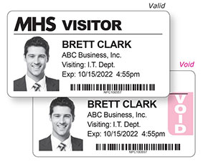
Add security to your visitor management system. No matter what it is.
It’s easy. Here’s how.
REPLACE your visitor badges with expiring visitor badges:
- On ROLLS for your label printer
OR
- In BOOKS that have a confidential duplicate record
(Ideal for multiple entrances or as a backup to your computer system)
Or just ADD EXPIRING STICKERS to your visitor badges.
No matter what you do now, you don’t have to change how you do things.
Contact us today!

