Expiring Visitor and Guest Stickers affordably help increase building security
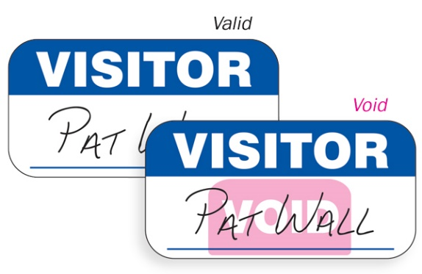 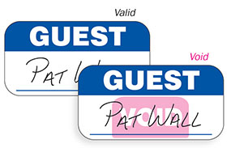
Specifications:
- Product comes in ROLLS for use with a pen.
- Size: 2 5/16" x 1 3/16"
- Quantity: 1,000 stickers per pack (2 rolls of 500 stickers)
- Price: $118 per pack (MSRP)
Contact us today!

