An easy upgrade to your visitor sign-in process
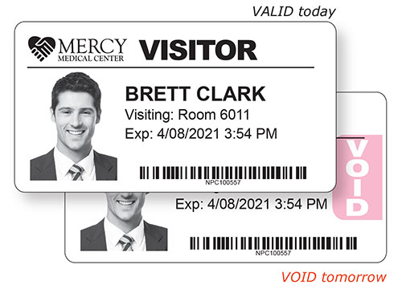
One-minute video shows how these extra-secure visitor badges fit YOUR software and printer.
Organizations that use expiring visitor badges give their sign-in process an extra layer of security.
When visitors’ badges are white, you know they signed in today. With “expiring technology,” these badges turn pink overnight. They may be valid today, but they become void tomorrow.
You can have the same expiring technology protecting your organization, with “self-voiding” visitor badges that fit your existing software program and printer, like the following:
Software:
- Easy Lobby  - Envoy  - eVisitor  - Fast-Pass  - HID SAFE  - iLobby  - iVisitor  - KeepnTrack  - LobbyGuard  - Lobby Track  - PassagePoint | - Proxyclick  - Raptor  - Reptrax (by IntelliCentrics)  - Savance Workplace  - Splan  - Symplr  - Traction Guest  - Vendormate (by GHX)  - Veriscan  - Well Screen  - WhosOnLocation
Printers:
- Zebra
- Brother
- Seiko
- DYMO (Not the 550 or 550 Turbo)
- Epson
- Primera
Try these badges for yourself, absolutely free!
Contact us today!

